Quality and Outcomes Framework (QOF) indicators
2017-18 year end achievement
(subject to verification)

Clinical indicators
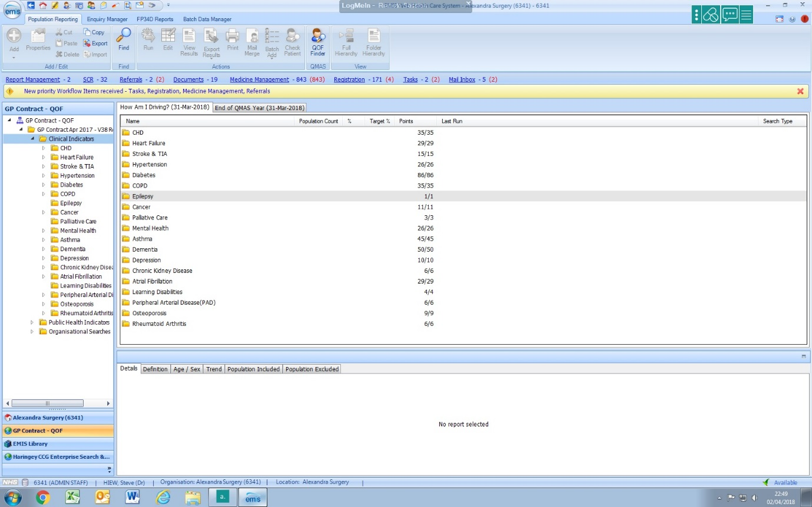

Public Health indicators
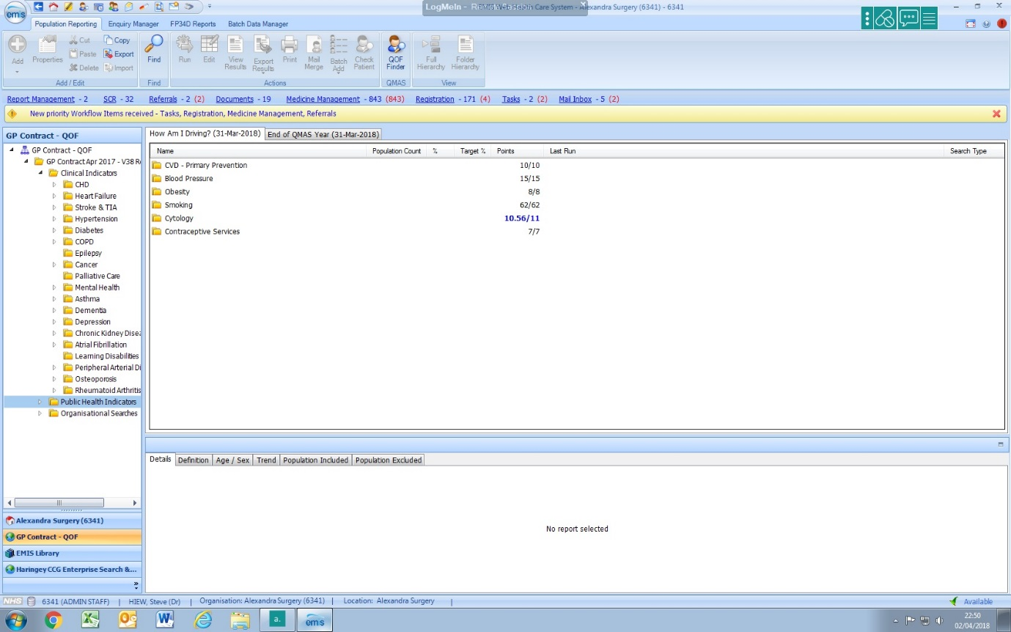

Organisational indicators
